Introduction to Biology  Biology 12 | Name:  Block:  Date:

You are an amazing multi-tasking machine. You can carry on, at any given moment, many different tasks. As you sit and ready this, your heart is beating, your digestive tract is breaking down your food, your eyelids are blinking to protect your eyes, and your muscles are keeping you upright and balanced. These important activities are all related to our body systems and how they coordinate with one another. Cells are multicellular organisms must demonstrate teamwork and cooperation in order for the organism to function.
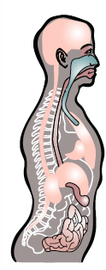
Your body is made up of an estimated 70 trillion cells. A cell is the smallest structural and functional unit in the human body. Cells perform the basic functions that keep us alive. They acquire nutrients, dispose of metabolic wastes, respire (produce ATP energy), synthesize molecules used by the cell and grow. Many cells undergo cell division.

A group of similar cells that perform a particular function is called a tissue. Several tissues join together to form an organ. Organs work together to form an organ system. Complex organisms such as humans are a collection of organ systems.

Systems are made up of individual parts that work together and are usually connected to one or more other systems. If one part of the system is damaged, the system will not function well or may not function at all. The human body is made up of interdependent parts that work together – understanding how these parts work help us to understand the whole system.

Questions:

- From the information provided as well as from your own prior knowledge, brainstorm what you already know about cells. Record this information using a list, or graphic organizer (such as a mind map, flowchart or table). You may even want to include a picture or diagram.

- Using an example of your own, complete the flow chart below:
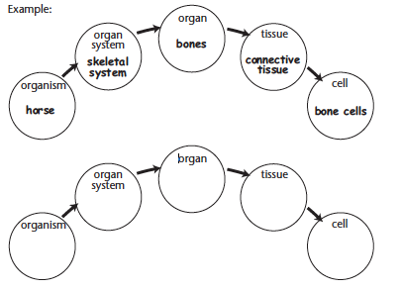
- You probably know a lot about the body’s systems from previous science courses, and from your day-to-day experiences. Match each body system listed below to its description, in the table.

Muscular
Digestive
Respiratory
Skeletal
Endocrine
Reproductive
Immune
Circulatory
Integumentary
Nervous
Excretory

Description | Body System
Transports blood and nutrients to the body
Allows organisms to take in, break down and absorb nutrients
Controls breathing and performs gas exchange n lungs and tissues
Removes wastes from the body
Cells in the body that protect the body from invaders
Manufactures and releases hormones
Includes organs for producing offspring
Includes skin, hair and nails and creates a protective barrier around the body
Forms the shape of the body; supports, protects and works together with muscles to move the body
Made up of muscles that work with bones to move the body
The control center for your body; signals your body to changes in your environment and coordinates your actions and reactions

- What would happen to the body if one of the body systems failed? Use an example to help explain.

