Life & Environmental Science 11  Science Processes | Name:  Block:  Date:

To answer questions 1-4, closely observe the garden pictured below.

- What observations can you make about the flowers on the east end of the garden?

_________________________________________________________________________________________________

- What observations can you make about the flowers on the northwest side of the garden?

_________________________________________________________________________________________________

- What observations can you make about the flowers on the southwest side of the garden?

_________________________________________________________________________________________________

- State a hypothesis that could explain the differences you observe.

_________________________________________________________________________________________________

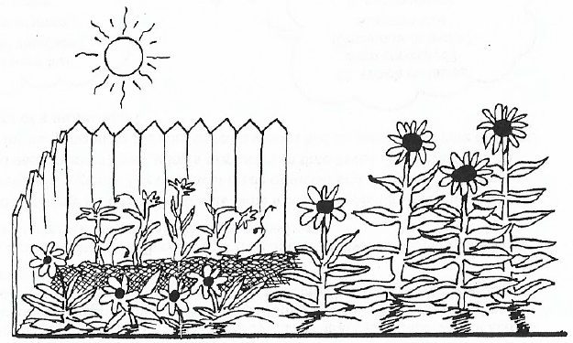

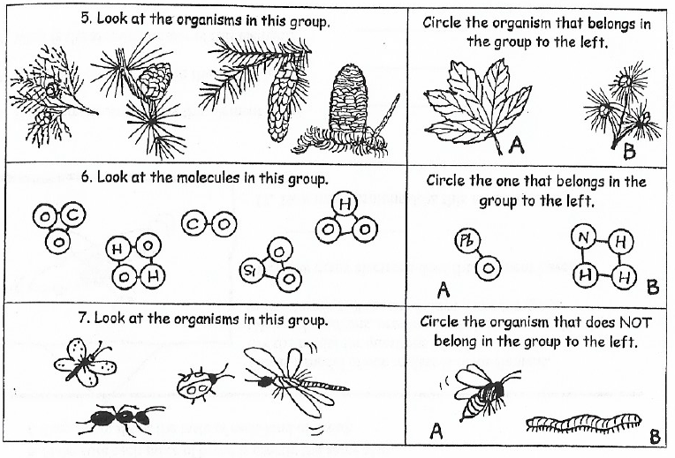

Use the plant diagram below to answer questions 8-10. Use a centimeter ruler for your measurements.

8. The plant grew about 30 centimeters between week _______ and week _______ .

9. What was the total growth shown over the 4 weeks? ______________________________________

10. How much growth occurred between weeks 2 and 4? ___________________________________

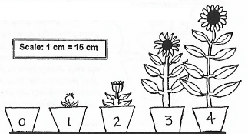

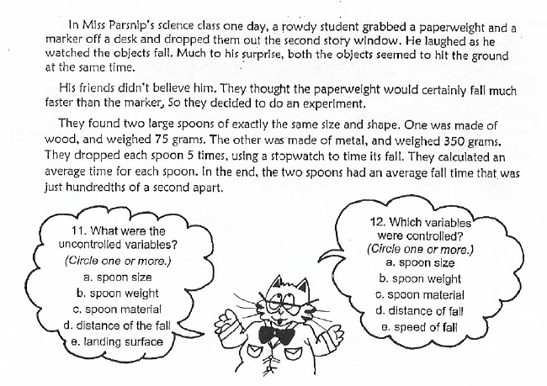
- How would you interpret the results of the experiment?

- If the students also timed the fall of a heavy plastic spoon (of exactly the same size and shape) weighing 200 grams, what results do you predict that they would find?

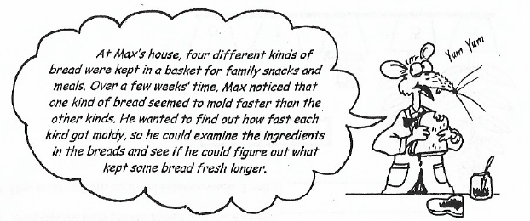
- When Max designs his experiment, which factors are important for him to include in his plan? (Circle one or more)
  - Start with four kinds of fresh bread, all baked the same day.
  - Store all kinds of bread in the same kind of container.
  - Look at the bread everyday and record observations.
  - Keep all kinds of bread stored at the same temperature.
  - Make sure each piece of bread is exactly the same size.
  - Keep notes about the taste of each kind of bread.
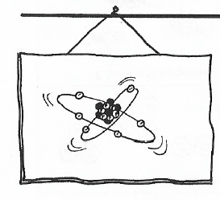

This is a model of one molecule of an element. Use the model for questions 16-20.
(Note: all neutrons, protons, and electrons are showing in the drawing. None are hidden from the eye.)

- How many electrons does this element have? ________________

- How many protons does this element have? ________________

- How many neutrons does this element have? ________________________________

- How many electrons are in the second level? ________________________________

- What is the atomic number of this element? ________________________________

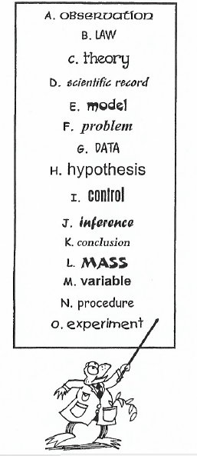
Match the science terms with their descriptions. Write a letter for each answer.

- _______ the amount of matter in an object

- _______ a series of steps used to test a hypothesis under carefully controlled conditions

- _______ a suggested solution to a problem

- _______a logical answer to a problem based on observations

- _______ something that can bring about changes in an experiment

- _______ an explanation of things or events (based on many observations)

- _______ an example of what might be seen if something could be observed

- _______ the way an experiment is carried out

- _______ a standard for comparison in an experiment

- _______ the meaning drawn from a conclusion

- _______ recorded facts or measurements gathered from an experiment

- _______ the things noticed by your senses

- _______ a statement that describes the way nature works (based on many observations)

- Which is an example of a scientific law?
  - Energy is neither created nor destroyed.
  - Dinosaurs disappeared from Earth because of a drastic climate change.
  - The universe began 15 billion years ago in a huge explosion called “The Bing Bang.”

- Which is an example of a scientific theory?
  - Ice melts when it is heated.
  - On Earth, an object that is dropped falls to the ground.
  - The surface of Earth is made of rigid plates that move.

- What would cause a scientific law or theory to be dropped?

- Why is it important for scientists to repeat experiments?

- Why is it important to have a control in an experiment?

- Why should a scientist test only one variable at a time?

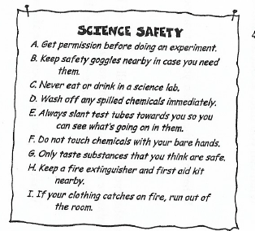
- A science student wrote up some rules for his science lab. Read them over. Cross out any that he has written totally or partially wrong.

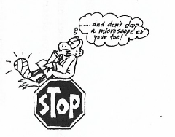

Observations, Inference, Hypothesis Worksheet

- Three goldfish are raised individually and grow to be a larger size than when raised in a group.

- What can you observe about the above situation?

- What can you infer about the above situation?

- What hypothesis can you state above the above situation?

- You observe that when a small amount of baking soda is added to a glass of water, gas bubbles form in the mixture and move to the surface.

- What can you observe about the above situation?

- What can you infer about the above situation?

- What hypothesis can you state above the above situation?

- A survey reveals that people who live within a 5 km radius of a chemical plant have a higher incidence of lung disease than people who live outside that area.

- What can you observe about the above situation?

- What can you infer about the above situation?

- What hypothesis can you state above the above situation?

