Biology 11  Chromosomes, Mitosis & Meiosis Review | Name:  Date:  Block:

- Match the following:

______ Loose strands of DNA & protein  ______ Condensed form of DNA  ______ Together, these make up equal parts of a chromosome  ______ The point at which two chromatids are joined | - Chromosome  - Centromere  - Chromatin  - Sister Chromatids

- Identify each of the following steps:
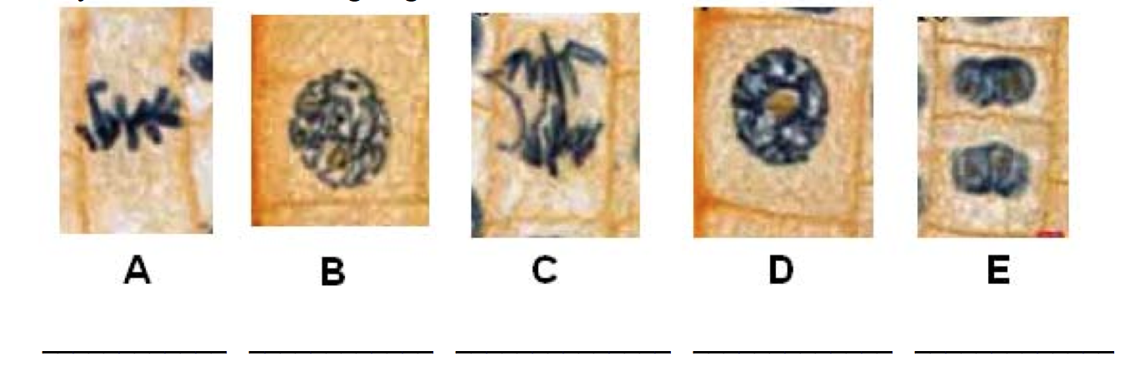
- Using the letters from the picture above, place the steps in the correct order of the cell cycle.

1: __________ 2: __________ 3: __________ 4: __________ 5: __________

- Examine the 18 drawings of the cells below. Write a letter of the stage of the cell cycle in the spaces below. Choices: Interphase (I), Prophase (P), Metaphase (M), Anaphase (A), Telophase (T)
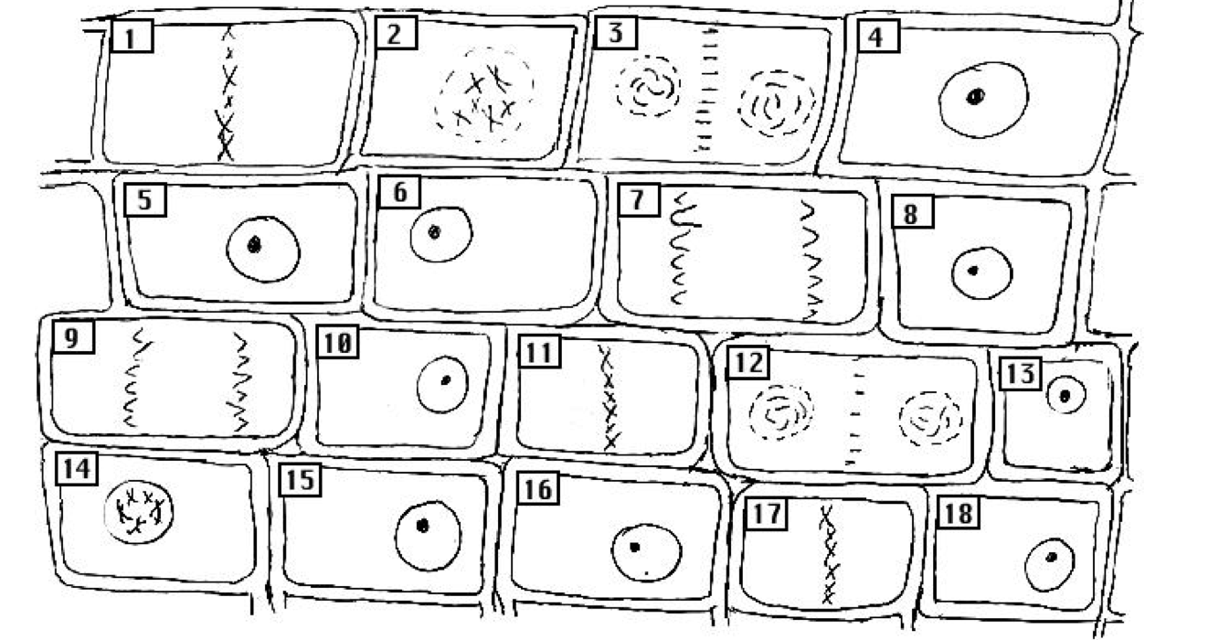
1 | 2 | 3 | 4 | 5 | 6
7 | 8 | 9 | 10 | 11 | 12
13 | 14 | 15 | 16 | 17 | 18
During which stage of the cell cycle doe the following events take place? Choices: Interphase, Prophase, Metaphase, Anaphase, Telophase

- _________________________ Chromosomes are split in half with each chromatid moving towards one end of the cell
- _________________________ DNA created or duplicated
- _________________________ Nucleus reforms
- _________________________ Chromatin winds into chromosomes
- _________________________ Spindle fibers form
- _________________________ Spindle fibers attach to centromeres of chromosomes
- _________________________ Cell performs its normal function
- _________________________ Spindle fibers pull chromosomes to middle of the cell
- _________________________ Nucleus dissolves
- _________________________ Cell enlarges

Are the following statements Mitosis, Meiosis or both?

- _________________________ Cuts the chromosome number in half
- _________________________ Part of sexual reproduction
- _________________________ The process if followed by cytokinesis
- _________________________ Keeps the chromosome number the same
- _________________________ 1 division
- _________________________ Creates 4 cells
- _________________________ Makes the gametes (egg and sperm)
- _________________________ Creates variation
- _________________________ Makes two identical daughter cells
- _________________________ Part of asexual reproduction
- _________________________ Makes the body cells
- _________________________ Involves the division of the nucleus to create new nuclei

- Draw the stages of mitosis in order. Make sure to have the phases included.

- Mitosis creates which cells? Circle all that apply

Skin Nerve Blood Egg Sperm Skin Brain

- Meiosis creates which cells? Circle all that apply

Skin Nerve Blood Egg Sperm Skin Brain

- In the space to the right, place the steps of meiosis in the correct order; label each stage as well. Number 1 has been completed for you
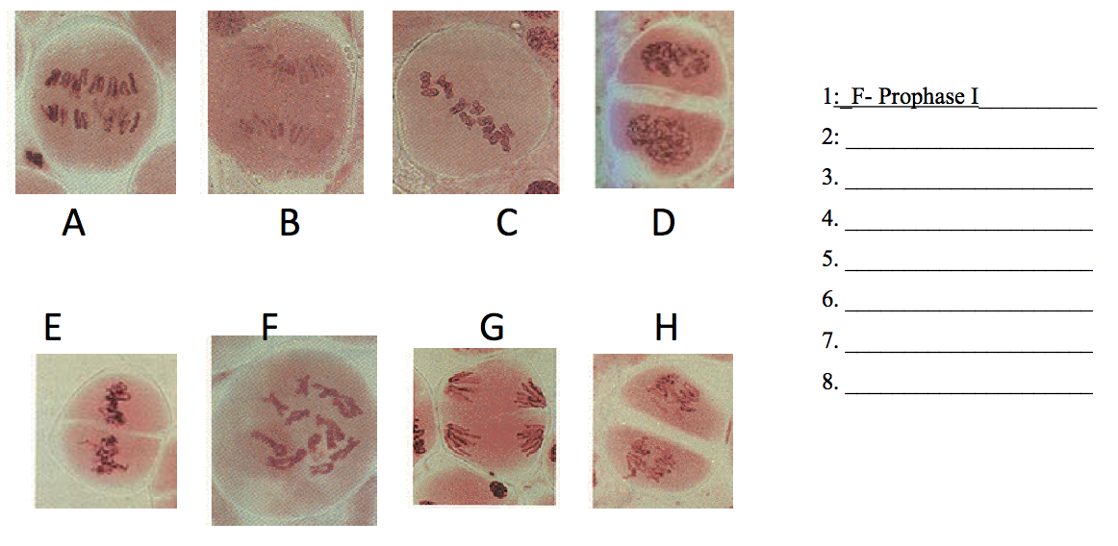
- Use the Venn Diagram to compare and contract Mitosis and Meiosis

