Biology 11  Bacteria Growth and Reproduction | Name:  Date:  Block:

Steps to Binary Fission
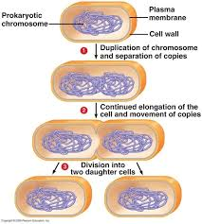
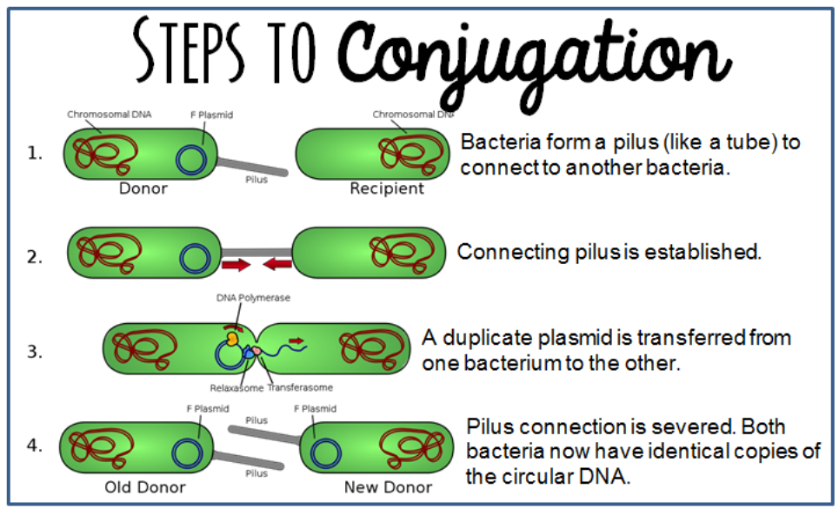
Steps to Spore formation
