Biology 11  Pedigree Charts | Name:  Date:  Block:

A pedigree is a visual chart that depicts a family history or the transmission of a specific trait. They can be interesting to view and can be important tool in determining patterns of inheritance of specific traits.

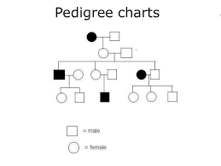
The Components of a Pedigree:

- Squares are used to indicate males
- Circles are used to indicate females
- If the individual is “affected” by the trait (dominant or recessive) we darken the shape
- A line between a male and a female indicates mating
- A line drawn down from the mating pair indicates offspring
- Sometimes, you will see some shapes filled in only half way this notation indicates a hybrid (heterozygous) or carrier of the trait
- Each level of the pedigree represents a generation

Analyzing Simple Pedigrees:

A pedigree is just like a family tree except that it focuses on a specific genetic trait. A pedigree typically only shows the phenotype of each family member. With a little thought, and the hints below, you may be able to determine the genotype of each family member as well!

Hints for analyzing pedigrees:
- If the individual is homozygous recessive, then both parents MUST have at least one recessive allele (parents will either be heterozygous or homozygous recessive)
- If an individual shows the dominant trait, then at least one of the parents MUST have the dominant phenotype. This one will be pretty obvious when you look at the pedigree
- If both parents are homozygous recessive, then ALL offspring will be homozygous recessive

NOTE: In a pedigree, the trait of interest can be dominant or recessive. Remember that the darkened shapes represent an affected individual, regardless of whether it is dominant or recessive trait.
Human Pedigrees

Example: Tracing the path of an autosomal recessive trait

Trait: Falconi anemia

Forms of the trait:

- The dominant form is normal bone marrow function – in other words, no anemia
- The recessive form is Falconi anemia. Individuals affected show slow growth, heart defects, possible bone marrow failure and a high rate of leukemia

A typical pedigree for a family that carries Falconi anemia

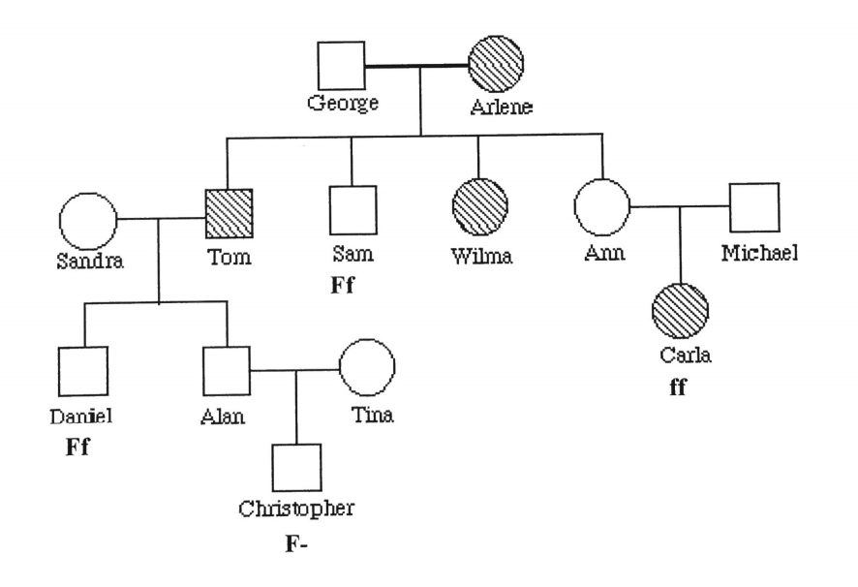
Analysis

Fill in the genotypes for each individual in the chart above. Use the letter “f” to indicate the recessive Falconi anemia allele, and the letter “F” for the normal allele.

List three people from the chart (other than George) who are most likely carriers (heterozygous) of Falconi anemia

