Science 8  Cell Theory | Name:  Date:  Block:

1.

2.

3.

Prokaryotic Cells

- Ex:
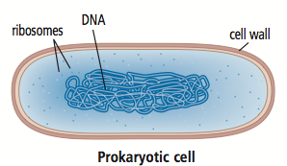

Eukaryotic Cells

- Ex:

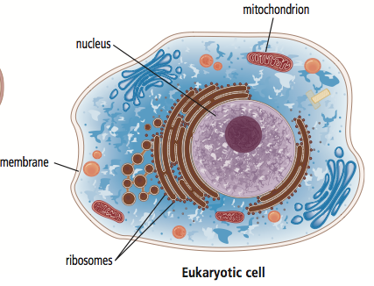

Prokaryotic Cells – Bacteria!

- Harmful:

- Helpful:

- Three different shapes:  1.  2.  3. | 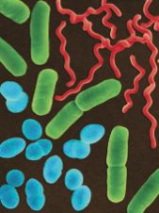
Viruses

- Take a look at figure 1.29 on page 34
Stage # | Description | Diagram
Stage 1
Stage 2
Stage 3
Stage 4
Stage 5

