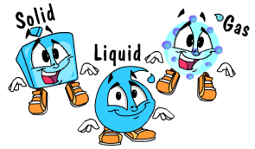 | Science 8  State of Matter  Kinetic Molecular Theory | Name:  Date:  Block:
Name something that is a…

Solid | Liquid | Gas

Solids, liquids and gases are STATES OF MATTER.

What’s a MATTER?

- MATTER is __________________________________________________________________________________________.
- Volume is ___________________________________________________________________________________________.
- How do we measure volume?
    - Usually in ________ or ________.
- Mass is _______________________________________________________________________________________________.
- The more __________ in an object, the more ___________ it has!
- How do we measure mass?
    - Usually in ________ or ________.

 | Fixed Mass? | Fixed Volume? | Fixed Shape?
Solid
Liquid
Gas

What is the explanation for this?

Particle Model of Matter
1.
2.
3.
4.
5.

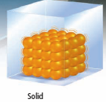 | 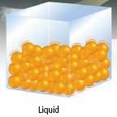 | 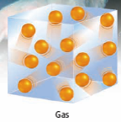

Kinetic Molecular Theory (KMT)
- Explanation what happens to matter when the kinetic energy of particles changes
- Kinetic energy = energy due to motion
- Particles are always moving! This means they have kinetic energy.
- Main points of KMT include…

According to KMT…
Solids: | Liquids: | Gases:

