Lab Station #1: Lab Area Safety
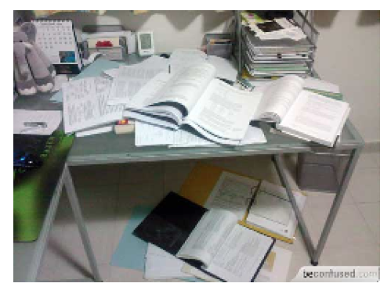
- Imagine this is your group’s lab area. What is wrong here?
- What might happen if your lab group had such a cluttered lab area?
- Write a lab safety rule for this station.
Lab Station #2: Lab Dress Code
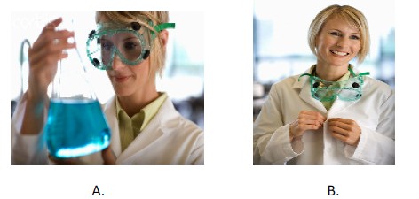
- Which picture accurately shows proper lab safety in the lab?
- Write a lab safety rule for this station.

Lab Station #3: Handling glassware

- What should you do if you break any of the glassware?

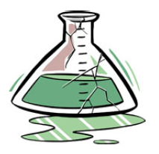

- Should you use the flask above? Why or why not?
Lab Station #4: Chemical Safety

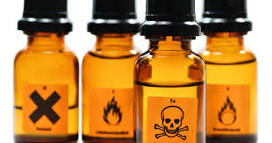

- Take a whiff of this unknown substance, what do you think the substance is?
- What is the proper way to smell a substance in the lab?
- Write a safety rule for this lab station.
Lab Station #5: Chemical Safety
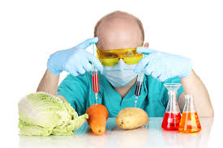
- If your lab partner told you to taste this unknown substance, what should you do?
- What do you think this substance is?
- Write a safety rule for this station.
Lab Station #6: Chemical Safety

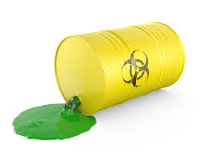

- If you spilled a chemical, what should you do?

Lab Station #7: Chemical Safety

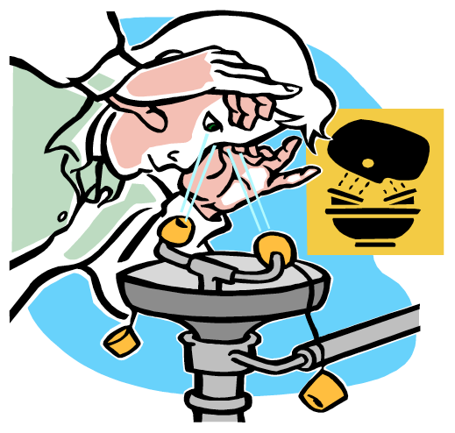

- What is the name of this safety equipment?
- When would you use it?
Lab Station #8: Chemical Safety

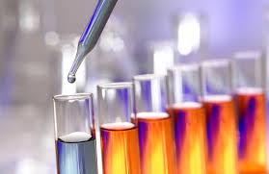

- If you did not use all of the substances given to you for your lab, what should you do with them?
- How would you dispose of substances used in the lab?
Lab Station #9: Fire Safety

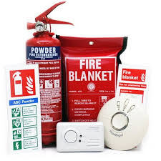
- Where is the nearest fire extinguisher?
- Where is the nearest fire alarm?
- Where is the nearest fire blanket?
- What 3 words do you remember about fire safety if your clothing were to catch on fire?
Lab Station #10: Clean Up
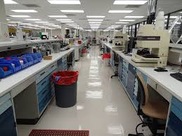

- What should you always remember to do before leaving the lab?

