Science 8  Plate Tectonics and Boundaries Worksheet | Name:  Date:  Block:

- Match the term with the descriptor:
Term | Descriptor
______ Continental drift theory | A. The region where magma breaks through Earth’s surface, continually forcing apart old rock and forming sea floor
______Plate tectonic theory | B. The large slabs or rock that form Earth’s surface and move over a layer of partly molten rock
______ Spreading ridge | C. The original super continent
______ Pangaea | D. The theory that the crust is broken up into large plats that move and then rejoin
______ Magma | E. A process that provides an explanation for continental drift
______ Mid-Atlantic Ridge | F. A long mountain range running north to south down the length of the Atlantic Ocean
______ Sea floor spreading | G. The most inner layer of the Earth
______ Convergent plate boundary | H. An area where tectonic plates are spreading apart
______ Divergent plate boundary | I. The most outer layer of the Earth
______ Transform plate boundary | J. An area where tectonic plates collide
______ Crust | K. The second most inner layer of the Earth
______ Mantle | L. Hot fluid below or within the Earth’s crust
______ Inner Core | M. The layer of the Earth where convection currents occur
______ Outer Core | N. An area where tectonic plates slide past one another
______ Tectonic plates | O. The theory that the continents have not always been in their present locations but have not moved over millions of years.

- What is a tectonic plate?

- What is the Mid-Atlantic Ridge and how was it formed?

- Identify the Mid-Atlantic Ridge on the map below.

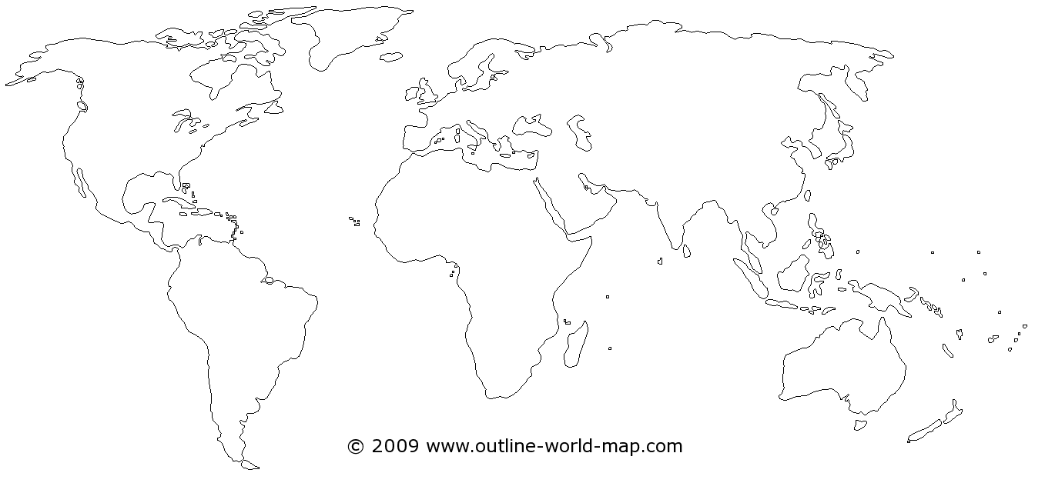

- Using your notes and/or the internet, describe the type of plate interactions that have occurred at the following geographic locations.

Geographic Location | Plate Interaction
1. East African Rift
2. Juan de Fuca Plate & North American Plate
3. Islands of Japan
4. Himalayan mountains
5. San Andreas Fault

- When continental plates collide, does subduction occur? Explain your answer.

- What geological feature is formed at subduction zones?

