Chemistry 11  Organic Chemistry II Check Point  - Naming & Drawing Alkanes | Name:  Date:  Block:
Name the following alkanes:

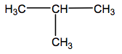 | _______________________________
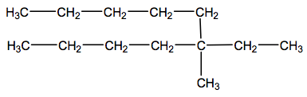 | _______________________________
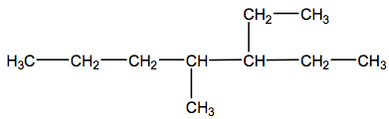 | _______________________________

Draw the following alkanes:

2-methylpentane

4-ethyl-4-propylnonane

2,3,4-trimethylheptane

Chemistry 11  Organic Chemistry II Check Point  - Naming & Drawing Alkanes | Name:  Date:  Block:
Name the following alkanes:

_______________________________
_______________________________
_______________________________

Draw the following alkanes:

2-methylpentane

4-ethyl-4-propylnonane

2,3,4-trimethylheptane

