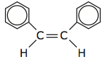 |  | Aromatic Hydrocarbons |  | Name:  Date:
1. | 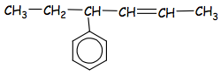
2. | 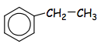
3. | 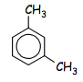
4. | 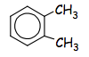
5. | 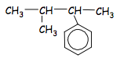
6. | 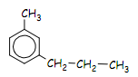
7. | 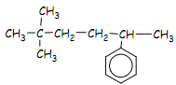

Draw the condensed structural formula for the following organic compounds:

- 2-phenylbutane
- 1,2-diethylbenzene
- 1,2,4-trimethylbenzene
- 3-methyl-2-phenylpentane
- 1,2-dichlorobenzene
- 4-phenyl-2-hexene 2) ethylbenzene 3) 1,3-dimethylbenze 4) 1,2-dimethylbenzene 5) 3-methyl-2-phenylbutane 6) 3-methyl-1-propylbenzene 7) 5,5-dimethyl-2-phenylhexane 8-12) see website

