Chemistry 11  Organic Chemistry III Check Point  - Cycloalkanes & Aromatic Rings | Name:  Date:  Block:

Name the following hydrocarbon:

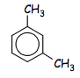 | _______________________________
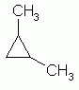 | _______________________________
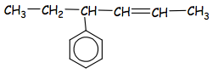 | _______________________________

Draw the following hydrocarbon:

3-ethyl-1,1,3-tripropylcyclobutane

3-methyl-2-phenylpentane

1-ethyl-3-methylbenzene

Chemistry 11  Organic Chemistry III Check Point  - Cycloalkanes & Aromatic Rings | Name:  Date:  Block:

Name the following hydrocarbon:

_______________________________
_______________________________
_______________________________

Draw the following hydrocarbon:

3-ethyl-1,1,3-tripropylcyclobutane

3-methyl-2-phenylpentane

1-ethyl-3-methylbenzene

