Chemistry 11  Organic Chemistry IV Check Point  - Alkyl Halides  - Alcohols  - Recognizing Functional Groups | Name:  Date:  Block:

Name the following hydrocarbon:

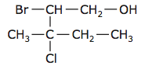 | _______________________________
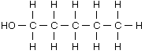 | _______________________________
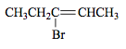 | _______________________________

Draw the following hydrocarbon:

3-fluoro-2-pentanol

3-chloro-2,2-dimethyloctane

Circle and identify the functional groups in the following molecules:

